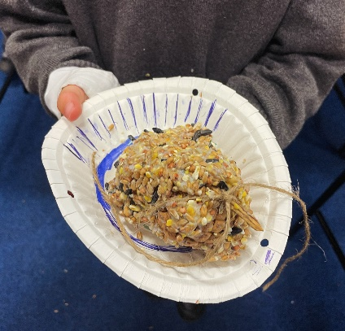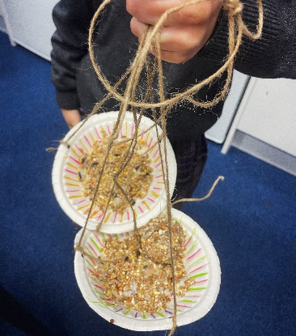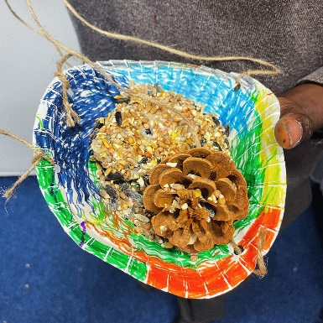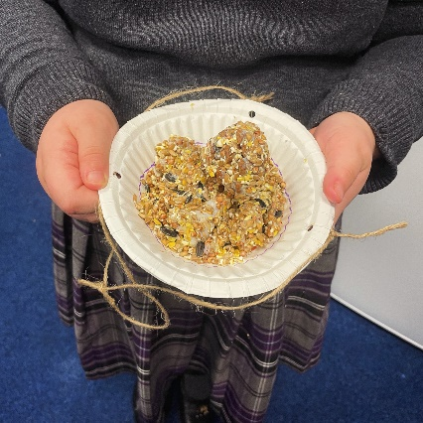

Session 7 Making Memories – Stop Pollution
We used the ‘Stop Pollution’ slogan - reduce, recycle or reuse and discussed our options and preferences and in a friendly debate to sort out different material into reduce, recycle or reuse categories. Thinking about the slogan, we:
- Recycled – plastic bottles, pinecones, old string
- Reused – plastic bottles and used paper plates into bird feeders
- Reduced – bought less provision for the garden (we made our own)

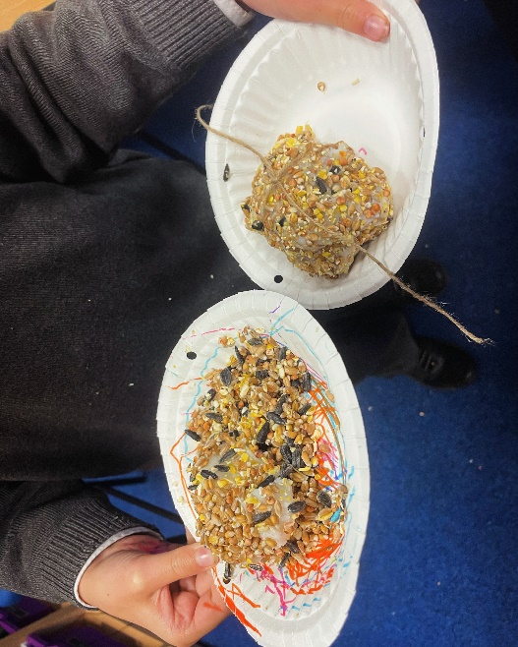
And we made our very own bird feeders together!
