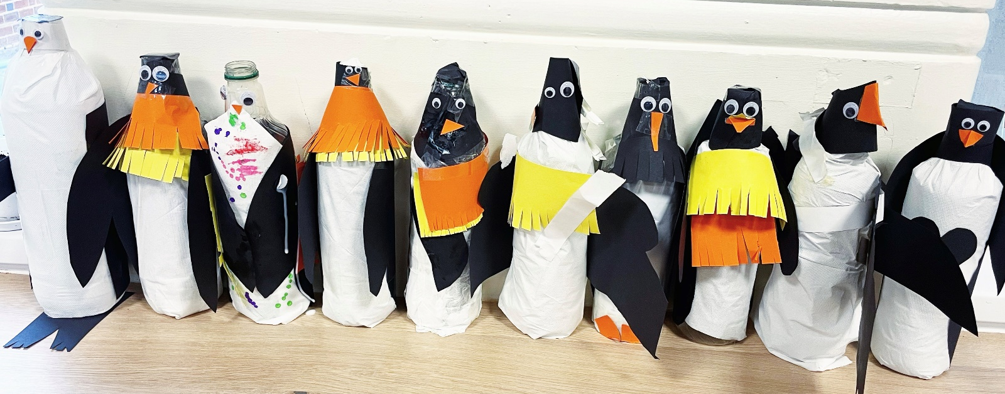
Making Memories Session 6 – Oceans and Penguins

During this session we explored oceans and how the ocean provides climate regulation. We thought about everything we had learnt already about recycling to explain how we would protect the ocean by reducing waste and using things like wooden toothbrushes and wooden ear cleaning buds instead of one-use plastic items.

We then used recycled bottles to make our own penguins and thought about why penguins are so important to the food chain and our oceans.
