Hollymount School
PASTORAL HANDBOOK

Guidance
This Handbook is written inline with the following Government Guidance:

- Education Act 1996
- Education Act 2002
- Equality Act 2010
- Education and Inspections Act 2006
- Health Act 2006
- Voyeurism (Offences) Act 2019
- The School Information (England) Regulations 2008
- DfE (2016) ‘Behaviour and discipline in schools’
- DfE (2021) ‘Keeping children safe in education 2021’
- DfE (2021) ‘Sexual violence and sexual harassment between children in schools and colleges’
- DfE (2018) ‘Mental health and behaviour in schools’
- DfE (2015) ‘Special educational needs and disability code of practice: 0 to 25 years’
- DfE (2013) ‘Use of reasonable force’
- DfE (2018) ‘Searching, screening and confiscation’

Contents:

- Introduction and the British and Core Values
- Rules
- Praise and Celebration
- Guidelines for the use of the zone board
- Restorative approach
- Consistency
- Report Card
- Peer on Peer incidents and actions
- De-escalation
- Pastoral Support Plan
- Incident Intervetion
- Physical restraints
- Recording of incidents
- Pupil Voice
- Pastoral referral form

INTRODUCTION
At Hollymount School the staff aim to give the children an enjoyment of learning through providing creative opportunities which nurture curiosity and engagement.

We encourage the children to take pride in their work and to be confident through motivation and celebrating achievements.

Through this the children achieve success, they develop ambition and persevere when things get tough and become independent learners.

Children are encouraged to have an understanding and respect for the wider community, showing an appreciation of other cultures and way of life. We value the environment we have built which is inclusive and promotes tolerance and acceptance of others.

Hollymount School children will encounter the principles of the British Values throughout everyday school life. These principles are implemented through the Trust and School’s Core Values:

Proud to be me

Children at Hollymount School are proud of themselves and their achievements. Opportunities are always given to children to develop their confidence and self-belief, which enables them to take on new challenges and persevere with new learning.

“I like to challenge myself and I learn from making mistakes” (Year 4)

Enjoy learning

Children enjoy all aspects of learning and are able to generate and extend their ideas, exploring possibilities. Children show their passion for learning through engagement and articulation of their views and, where appropriate, sharing these views through a conjecturing atmosphere.

“I like to join in with the discussions in class as everyone listens to me.” (Year 3)

Achieve success

All children strive to achieve their best at Hollymount School. They become successful learners through developing a high-level of ambition and recognising how this can be achieved. The children do this by continually seeking ways to improve and persevering in all areas of the curriculum.

“I always try my very best and my teacher lets me know how well I have done all the time.” (Year 1)

Respect for the world

Children at Hollymount School are respectful learners; they value and celebrate diversity. The children respond appropriately to their peers and all adults – understanding the role and responsibilities of all stakeholders. All children understand what it takes to be a good citizen and will challenge disrespectful behaviour, where appropriate.

“I have learnt how to behave in and outside of school and who can support me and my friends.” (Year 6)

The school environment supports this document:

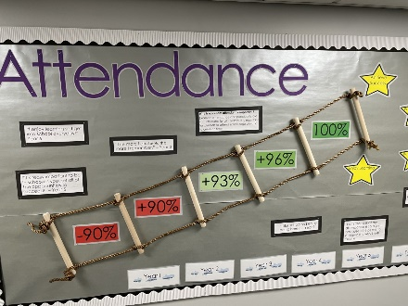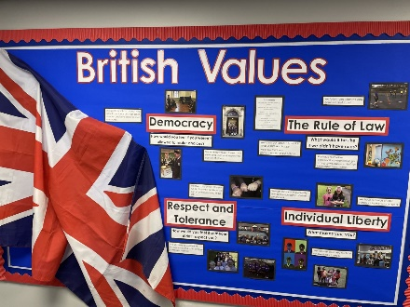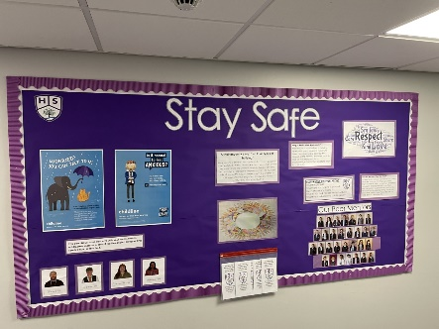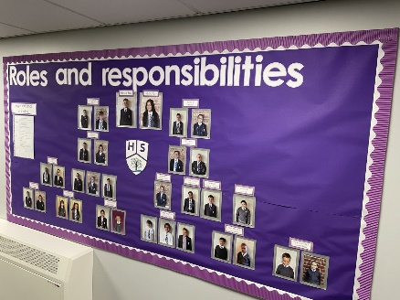

RULES

The following rules were developed by the whole school. Staff and pupils worked together to discuss helpful and hurtful behaviours and how we could avoid the latter. This supports the school community by aiming to allow everyone to work together in an effective and considerate way, to help pupils to grow in a safe and secure environment, and to become positive, responsible, and increasingly independent members of the school community.

We treat all pupils fairly, in a consistent way, it is vital that pupils understand these rules and that we apply them consistently. Pupils must be given clear warnings and reminded that they need to be responsible for their own choices and actions.

The school rewards good behaviour, as it believes that this will develop an ethos of kindness and co-operation.

This school’s behaviour policy is designed to promote good behaviour, rather than merely deter anti-social behaviour. (Please see the Behaviour Policy)

- We follow instructions the first time of asking
- We work and play without hurting or disturbing others
- We listen without interruption, respecting others, their values and opinions
- We look after our school environment and everyone’s property
- We move around school safely and stay in safe places

COVID:

Clean your hands regularly with soap and water
Out of your mouth – keep your hands away from your nose, eyes and mouth
Move safely around the school
Be alert, stay safe!
Always stand 2 meters away from pupils and adults
Tissues – keep them on you and dispose of them immediately after coughing or sneezing
PRAISE AND CELEBRATION

We praise and reward pupils for good behaviour in a variety of ways:

Housepoints:

Each child is assigned to a house when entering the school. Pupils receive house points for a variety of reasons related to our 5 school rules, these may include:

- Excellent work in class or at home
- Exemplary behaviour
- Consistently smart uniform
- Supportive behaviour towards other pupils

Each week the current total of each house’s house points are announced in assembly so the pupils can hear and see which house is winning. The winning house at the end of each term receives a small prize.

Prizes

When pupils earn 10 housepoints or under the teacher’s discretion, they will automatically receive a Super Student token, these tokens can be spent in our reward shop (Housepoint prizes). Pupils may choose to spend one token or to save their tokens to buy larger gifts.

Positive postcards

All members of staff are able to send Positive Postcards home to all pupils. These may be sent home for outstanding effort or acts of kindness, civility or helpfulness within school and the local community.

Certificates

Each week the school holds an assembly to celebrate excellence where pupils are given certificates for having an outstanding attitude towards learning. As a school we acknowledge the efforts and achievements of pupils out of school in our weekly assemblies and on the newsletter.

GUIDELINES FOR THE USE OF ZONE BOARD
In school we use the zone board so that all pupils can visually see and be rewarded for their behaviours. We have an ethos of ‘it’s good to be green.’
The aim of the boards is to provide adults with a non-confrontational, visual way of reinforcing appropriate pupil behaviour that is in line with the classroom rules.
These rules need to be displayed near to the boards and they need to be embedded by being referred to regularly. At the beginning of each term the children should discuss the rules and the expectations of good behaviour and what is expected to achieve silver and gold.
All pupils begin each day in the green zone every morning and at the beginning of the afternoon so that a ‘fresh start’ can be applied.
We believe that the emphasis should be on positive praise and highlight when pupils are doing well. Staff should be reinforcing appropriate behaviour at the ratio of 3:1 (3 pupils go up the board for keeping the rule that 1 pupil has chosen to break.)
The amber zone is the warning zone with a minimal consequence which is designed to afford pupils some time to make the right choice about his/her own behaviour. Before moving a pupil to amber one verbal warning must be given with time to change their behaviour. This warning should include what they are doing wrong and what they can do to put it right. If a pupil is place in the amber zone that means that they will miss 5 minutes of their break or lunchtime depending on what comes first.
If a pupil displays red behaviour or does not change their amber behaviour they will be placed on the red zone on the board. This means that they will lose 15 minutes of their lunchtime. The pupil will be told why they are on the red zone and how they could have changed their behaviour so that they may change their behaviour in the future.
Any pupil who drops into amber or red will only be able to end the day in green or silver – not gold.
Movement should be up and down the coloured zones – not within a zone unless a zone board ladder is used.
The teacher must use his/her judgement about how often the names are moved on the board. The effectiveness can be lost if pupils are moved from red back to green too quickly. Some pupils might benefit from returning to green slowly via the ladder.
Only adults are allowed to touch the names on the board, this adds gravitas to the action. It is more effective if the names are moved during the lesson rather than all at the end. Staff are encouraged to move pupils’ names on the board without discussion or disruption to the lesson. A quiet word of explanation can be given later but any argument from the pupil will result in a further move down. All adults using the board need to agree on the reward for ending the day in silver or gold.
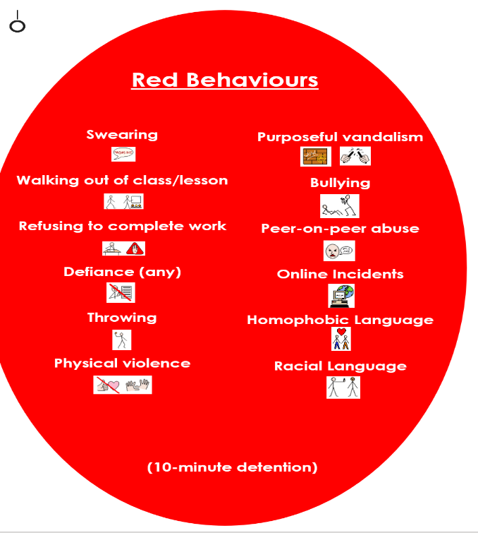
Zone boards are a simple tool. The real test as to whether they are being used correctly is if the pupils are keeping the rules! Below are the actions that may put a pupil in the different zones:
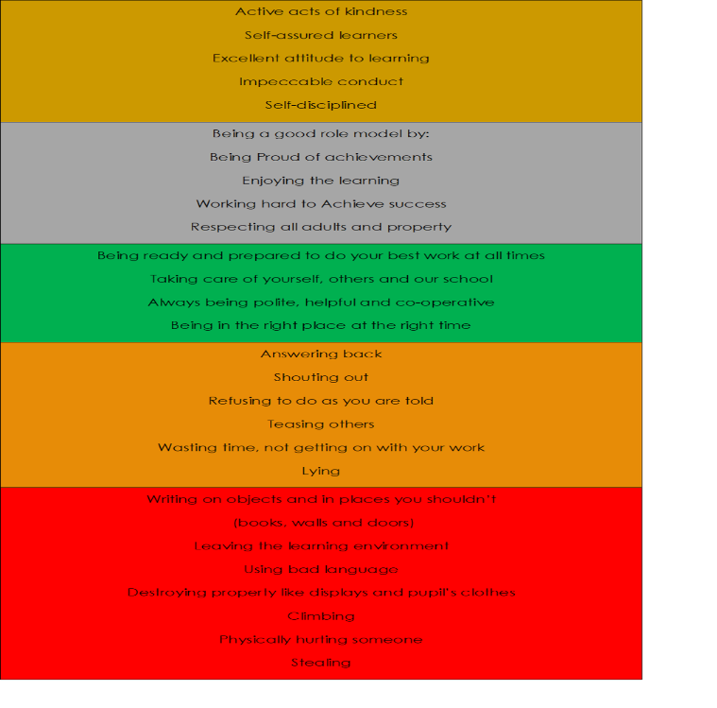
If an incident of abuse occurs – such as homophobic language, a member of SLT will be infiormed of this and action(s) will be carried-out. This is recorded on Scholar and followed up immediately. Pupils are educated on all matters that arise.
When the child is ready for ‘Time for talk’ this provides them with an opportunity to discuss what has happened and discuss the emotions they displayed on a 1:1 basis.
Once this has occurred and the child is regulated and has been able to ‘name it to tame it’ it may be a requirement that some restorative justice needs to take place as other children may have been involved in the situation and will provide closure. This will involve all parties and will enable all parties involved to understand their own emotions and the emotions of others and agree a resolution to the situation. The discussion will include what can be put in place to ensure that it does not happen again or if the situation does occur what could be done differently.
RESTORATIVE JUSTICE
This is when the incidence of negative behaviour is dealt with in a fair, respectful and appropriate way, with the key focus on individuals taking responsibility for their behaviour, repairing any harm done, rebuilding, and restoring relationships. The key principle when dealing with issues is to give all the people involved a chance to have their say and become actively involved in the process. All members of staff and children know that issues will be dealt with fairly with a ’no blame’ approach.
When there have been incidences between two or more children, key questions will be asked to find out what has happened and how the individuals involved can make things right again, or repair the harm caused. Our aim is not to ask ‘Why?’ something has happened but to determine what has led up to an issue and resolve it in a positive way. Everyone involved in an incident is taken through Restorative dialogue and is therefore supported in coming to understand the harm that has been caused to all parties.
The Restorative Questions:
- What happened? Drawing out each person’s story one at a time, starting with the person who has caused the harm. The aim is not to come to a definitive conclusion on what has happened, but for each person to have their point of view listened to.

- What do you think and feel about that? What each person was thinking and feeling at the time, before and since.

- Who has been affected and how? Who has been harmed/affected and how? Older children are encouraged to think about the wider implications of who has been affected e.g. families.

- What are the needs of those involved? What those affected need to feel better, move on, repair harm and rebuild relationships.

- What do you think needs to happen next to make things right with each other and with the school community? How do those people agree and negotiate meeting the needs identified above and what support might they need to do this? Staff support pupils in this process but try to ensure the pupils form their own agreement when possible. The children can refer to the zone boards to consider how they can make appropriate amends with the high expectations of the school community.

This approach encourages those involved to identify ways in which a relationship can be repaired or how they can move forward. By giving pupils this responsibility, we are supporting children in developing their own strategies for avoiding and resolving conflict. That if pupils reach their own agreement as to how to move forward after a conflict, they are more likely to abide by it than if it is suggested by an adult or imposed upon them. By involving the pupils in the design of the agreement we give them ownership over it and ensure it is helping them to resolve the situation and make amends in their own way.
Our Peer Mentors also play a part in supporting the pupils. During recreational time, peer mentors are placed around the playground. They are there to carry-out various conversations with their peers. This is in place to identify and pupils who feel that they need to share any concerns. This will then be passed onto an adult who will deal with the situation. The mentors know that this information will have to be shared. Peer mentors are identified by wearing hi visibility jackets and wear the restorative lanyards. Peer mentors and adults all have the restorative questions on a lanyard, around their necks as a prompt. Please see below:
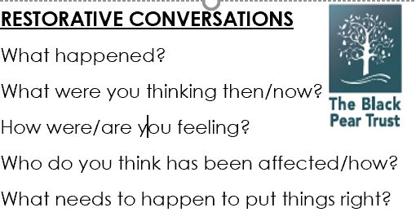
CONSISTENCY
Children’s behaviour can be a way of them trying to communicate. Understanding their needs and triggers gives us the opportunity to respond differently to our children. Entering into confrontation/ raising your voice/attempting to intimidate a child or in some extreme cases communicating verbally with some children will not result in the situation becoming quickly resolved. For some children they find it necessary to engage in behaviour that seems destructive, physically, emotionally or socially. Sometimes children feel unsafe or out of control, so they take inappropriate action over the things they can control, like being able to kick someone.
Some children have genuine difficulties and find emotional self-regulation difficult; this may be due to previous or ongoing maltreatment or abuse; other children may not have had appropriate responses modelled to them.
Re-educating children with appropriate responses and helping them to self-regulate is a long process!
Consistency with discipline is vital but a child must be in a place to hear this, accept it and respond appropriately. To ensure a calm and purposeful climate we must learn to read our most vulnerable pupils – they may exhibit very subtle micro-expressions - and react accordingly.
REPORT CARD
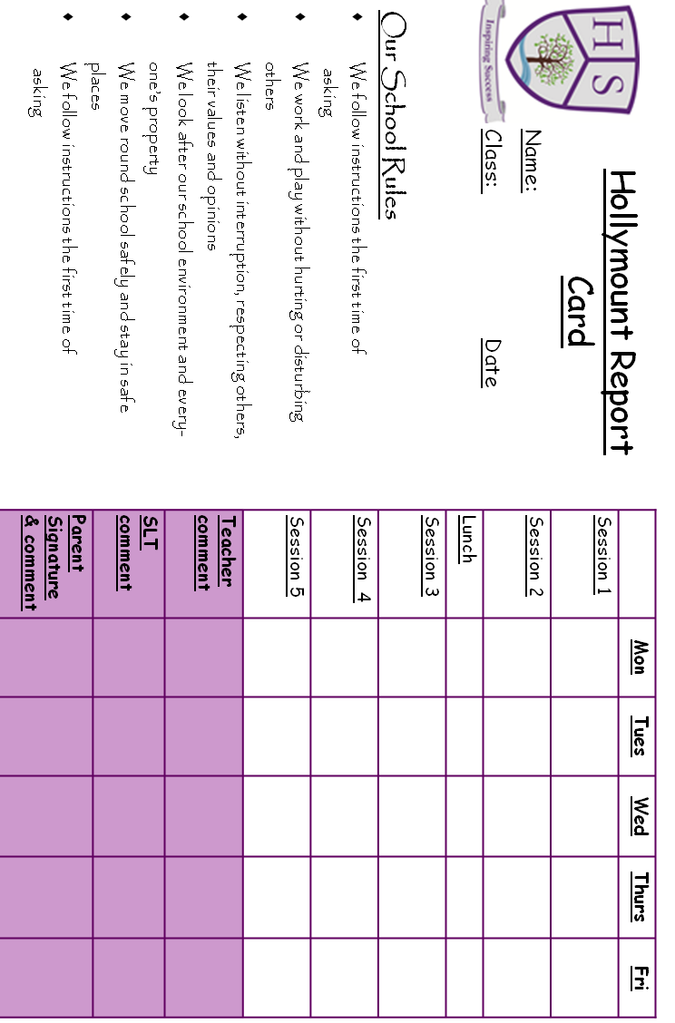

Following the school’s behaviour policy, a pupil will be put on report if there are 3 incidents in a short period of time (normally 3 weeks). This will support correspondence between parents, teachers and SLT.

PEER ON PEER INCIDENTS

Below is an example of the peer-on-peer risk assessment used when dealing with incidents:

All actions are recorded on Scholar – via the parent and conduct tab - and follow the school’s procedures on safeguarding and Pastoral.

Basic information
Referrer Name and role
Referrer Contact details (email address and phone number)
Name of school(s) for victim(s)
Name of school(s) for child/ren alleged to have caused harm
Did incident occur on school premises? If not where did the incident occur?

considerations | RISK (consider victim, Child alleged to have caused harm, other pupils and staff) | Risk Level (High, Medium or low) | actions to reduce risk | Revised Risk Level (High, Medium or low)
What is the incident?
Who was involved?
Where did it happen
Does this incident constitute a crime? Assault, sexual assault, rape, sharing of indecent images of children, etc etc. As such has this been referred to the police?
Is it necessary to limit contact between the children involved?

Is there an actual or perceived threat from the child alleged to have caused harm to the victim and/or others?
Is either the victim or the child alleged to have caused harm at risk of physical harm as a result of this incident (for example, bullying or ‘retribution’ by peers)?
Do they share classes?
Do they share break times?
Do they share peer/friendship groups?
Do they share transport to/from school?
Are they likely to come into contact with each other (or anyone else involved in/with knowledge of the incident) outside of school?
How can such contact be limited?
Is there a risk of harm from social media and gossip?

Further action taken by the school or college: Please complete for each child involved.

Action | YES/NO | Date
Police informed
Referral to MASH
Referral to external support services
Referral to internal support services
Referral to CAMHS
Referral to early help
Other

DE-ESCALATION
Our policy of warnings / movement on the zone board is applicable but must not be done when a vulnerable child is exhibiting signs of high levels of anxiety.
When a child has de-escalated consequences can be explained. It may also be appropriate to employ restorative justice techniques.
In a relatively small number of circumstances usual classroom discipline and behaviour plans may be insufficient and a different approach is needed to manage children and young people’s behaviour in a way that keeps them, the other children in the class and school staff physically and emotionally safe. Underpinning the success of managing the diverse needs that will be present in each classroom is the skill of the teacher in intervening early to de-escalate situations calmly when they arise.
However, de-escalation is difficult, often the techniques go against our natural fight-or-flight reflexes. Remaining calm, professional and objective is not always easy and therefore it is a skill that will need to be practised in order to respond in a different way when a challenging situation occurs.
Reasoning with an angry child is not always possible, the aim of de-escalation is to reduce the level of agitation so that at an appropriate time discussion becomes an option and a better outcome can be achieved.
When to de-escalate:
De-escalation techniques are most successful when used early, before the child or young person becomes physically challenging or dysregulated. To do this, it is necessary to be aware of and spot early signs of agitation such as:
- Clenched fists;
- Fidgeting;
- Shaking;
- ‘Eye-bawling’ another child;
- Head thrust forward;
- Clenched jaw;
- Speech becoming more rapid or high-pitched or louder.
It is often possible to minimise behaviours that may lead to physical harm or danger to self or others by taking action early — immediately before or as behaviour begins to escalate.
Ignoring escalation and not addressing its cause can increase the frequency and/or severity of the behaviour.
Therefore, it is important for teachers to identify the triggers that cause concerning behaviour and to recognise the early signs of escalation. This will provide an opportunity to apply strategies that reduce, rather than heighten, an emerging situation. In turn, this approach will help to reduce restraint and seclusion incidents, while enhancing opportunities for pupils to learn pro-social skills.
The large part of what we communicate is through body language, much is through the tone of our voice and there are estimates that just 7% is through the words that we use. It is useful to remember this when you are trying to de-escalate. Ensure you are modelling the behaviour you want the child to emulate, relaxed and open body language can be helpful.
Non-verbal techniques include the following.
- Appear calm and self-assured. Make sure you are not displaying the same signs of agitation that can be seen in the child, unclench your fists, do not hold eye contact for too long and avoid standing square to the child;
- Maintain a neutral facial expression. Even our eyebrows can indicate we are surprised or angry, and similarly our mouths can betray our emotions unwittingly. Another natural reaction we often have when under stress is to smirk or giggle, which must be controlled;
- Allow space. Entering a person’s personal space can be useful to refocus on a task when the situation is calm, but when a child is agitated this can indicate aggression and escalate the situation. Staying some distance away will also help keep you safe should the child become physically aggressive;
- Control your breathing. When we are stressed, angry or tense, our breathing becomes more shallow and rapid. If we take deeper, slower breaths, this will not only help keep us calm, but the child will begin to match our own breathing pattern. It can sometimes help to match the child’s breathing initially then gradually slow it down.

If a pupil is becoming agitated, but their behaviour is not placing them or others at an imminent threat of physical harm, school staff should employ targeted de-escalation tactics to prevent behaviours from further escalation and to address the cause of the escalation.
Some recognised de-escalation strategies include:
- using active listening techniques (LEAPS — listen, empathise, ask questions, paraphrase and summarise actions for moving forward)
- acknowledging the pupil's underlying or expressed emotion (anger/distress)
- problem solving with the pupil to address the cause of escalation if safe to do so
- keeping verbal instructions simple and minimal, using a calm tone of voice and clear, direct language or pupil's preferred method of communication (focusing on the behaviours you want them to display rather than the ones you don't)
- adopting a non-threatening body stance and body language (open, relaxed with hands down)
- allowing adequate personal space
- using non-verbal cues
- distracting the pupil from the source of any anger or distress by discussing another topic they are interested in
- providing options (within limits) to help the pupil feel they are still in control of their decisions
- going to an alternative space with the pupil that is less stimulating or removes access to the triggers
- change of face
- go for a walk
- allowing time to change their behaviour
- name it, to tame it
- breathing techniques
- mindfulness
- silence
- lower your voice and keep a calm tone
- provide choices
When attempting to de-escalate a pupil's behaviour, staff members should observe whether the pupil's agitation is diminishing or if the behaviour is continuing to escalate. If it appears the behaviour is escalating to the point that it is placing the pupil or others at an imminent threat of physical harm or danger the staff member present will need to move from a de-escalation approach to incident intervention.
Important to note:
- Do not make threats or promises you cannot carry through, such as threatening to exclude the child;
- Do not be defensive or take it personally. What is being said may seem insulting and directed at you, but this level of aggression is not really about you;
- Do not use sarcasm or humiliate the child.

PASTORAL SUPPORT PLAN
For pupils with a pattern of behaviour escalation, effective de-escalation techniques should be detailed in an Individual Health Care Plan and supported by a Pastoral Support Plan. Please note that de-escalation does not include restraint.
Teachers and other staff who are likely to be in close contact with that pupil should be familiar with the strategies outlined in the plan. Including parents/carers in this planning process is important, as the use of consistent de-escalation strategies across both school and home environments will help to make sure these strategies are effective and do not cause confusion for the pupil. The school also has a behaviour specialist who can support pupils in various ways.
Example PSP:
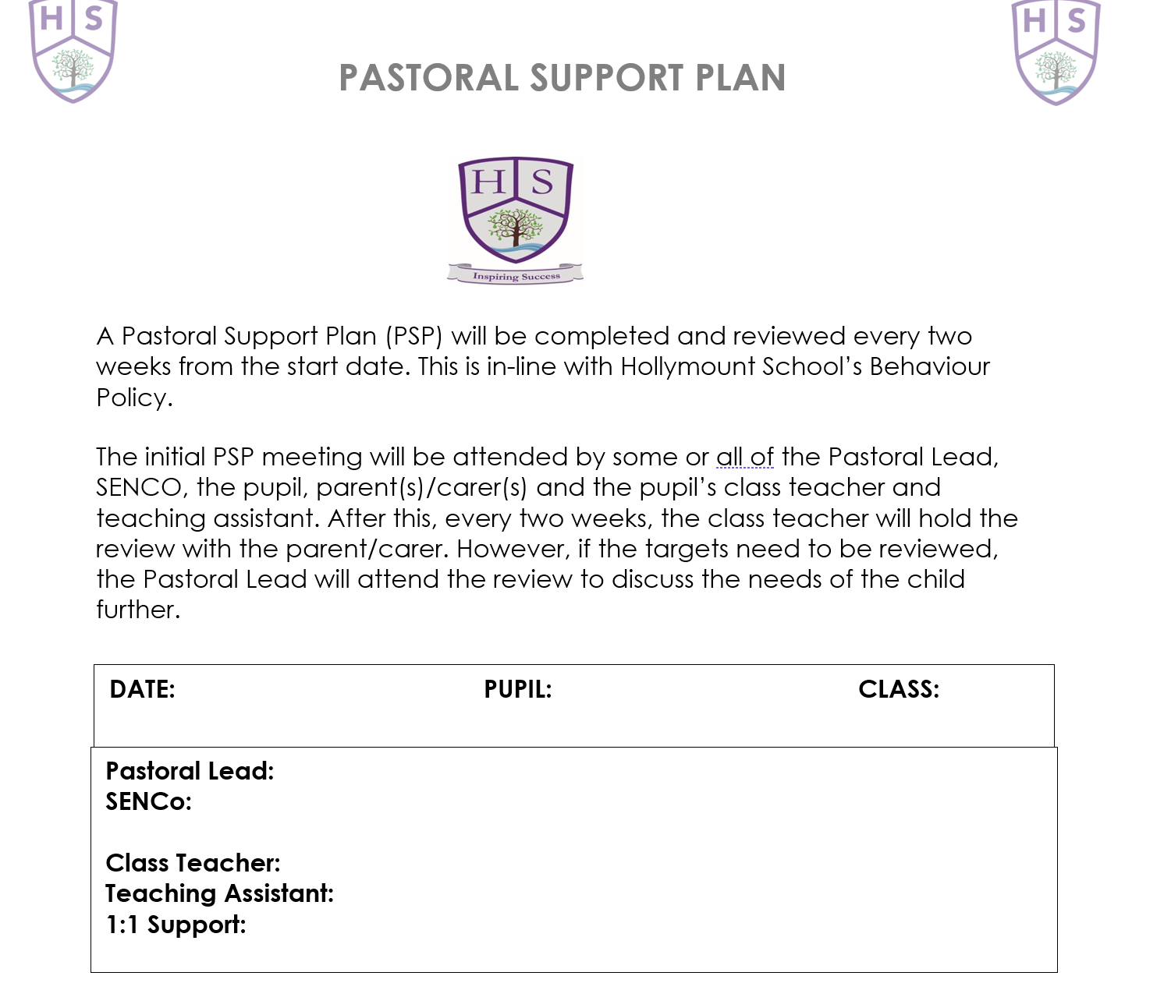
INCIDENT INTERVENTION
Occasionally a pupil's behaviour may reach the point where it threatens the safety of themselves or others.
This may occur following a period of escalating behaviour, when de-escalation techniques have been employed but have not been effective, or in situations where escalation has been quick and unpredictable.
Where possible, staff members should:
- focus on protecting the safety of all pupils (including the pupil at risk of causing physical harm or danger to self or others), themselves and other staff
- use intervention that is proportionate to the situation and has regard to the dignity of the pupil
- seek help from school leadership and other staff members to manage the incident
- move all other pupils in the vicinity to a safe distance away from the pupil exhibiting concerning behaviour
- if safe to do so, remove objects that may be used to cause harm away from the pupil
PHYSICAL RESTRAINT
Physical restraint is the use of physical force to prevent, restrict or subdue movement of a pupil's body or part of their body. Pupils are not free to move away when they are being physically restrained.
Physical restraint should not be used except in situations where the pupil's behaviour poses an imminent threat of physical harm or danger to self or others and restraint should be avoided to the greatest extent possible without endangering the safety of pupils and staff. See the positive handling policy for further information. All incidents are recorded in the Positive Handling Book, which is located in the school office.
RECORDING OF ALL TYPES OF INCIDENTS
Please follow the following flow chart:
- Using Scholar, select the pupil who you need to record an incident about.
- Select the Conduct Tab.

- Select the are in which you need to record.

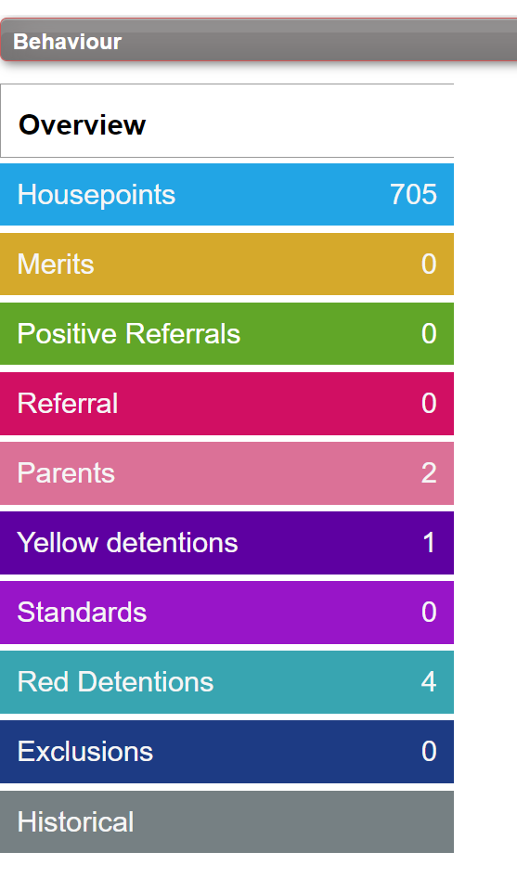

- Once you have recorded the incident, ensure that you recorded the restorative conversation that was carried-out.
- Submit the incident.
- If a parent is notified, please record this too.

PUPIL VOICE
Pupil Wellbeing
Results
Pupils in each class are selected, randomly, to complete the survey below at the end of each term:
 | Happy | Okay | Unsure | Sad
How I feel when I am at school
How I feel when I am at home
How I feel when I am with my friends
How I feel when I am I the classroom
How I feel when I am on the playground

As part of the monitoring cycles, pupils in each year group were asked a number of questions relating to the following:
- How to keep safe – in and outside of school
- Behaviour and the school rules
- Restorative practice
- Emotional support and where to seek it
- Aspirations
- Peer on Peer abuse

PASTORAL REFERRAL FORM
Name: |  | Year: |  |  | Date:
Referral for: (please tick)
Speech and language needs | Social needs |  | Mental health needs |  |  | Health needs | Learning Needs
Describe behaviours/difficulties displayed:

Describe what you have put in place already:
What would you like to happen?

What involvement have the parents had to date?

Signed: |  |  |  | Date:
Submitted to (name): |  |  |  | Date:
Actions and Dates: |  |  |  | Signed:

ET SHEET

